Lewellen Group

New Perspectives Excel 2019 | Module 5: End of Module Project 1



GENERATE REPORTS FROM MULTIPLE WORKBOOKS

# GETTING STARTED

* Open the file **NP_EX19_EOM5-1_*FirstLastName*_1.xlsx**, available for download from the SAM website.
* Save the file as **NP_EX19_EOM5-1_*FirstLastName*_2.xlsx** by changing the “1” to a “2”.

If you do not see the **.xlsx** file extension in the Save As dialog box, do not type it. The program will add the file extension for you automatically.

* To complete this SAM Project, you will also need to download and save the following data files from the SAM website onto your computer:

Support_EX19_EOM5-1_2021.xlsx

* With the file **NP_EX19_EOM5-1_*FirstLastName*_2.xlsx** still open, ensure that your first and last name is displayed in cell B6 of the Documentation sheet.

If cell B6 does not display your name, delete the file and download a new copy from the SAM website.

* PROJECT STEPS

1. Lonnie Holtzman is a financial analyst for the Lewellen Group, a management consulting firm headquartered in Providence, Rhode Island. The firm also has offices in Charlotte, North Carolina; Milwaukee, Wisconsin; and Denver, Colorado. Lonnie is using an Excel workbook with multiple worksheets to create a profit and loss statement for the firm. He asks for your help in completing the statement.  
   Go to the *Dashboard* worksheet. Lonnie first wants to complete the list of links in the range H7:H10. In cell H7, create a hyperlink to the **www.lewellen.example.net** website.
2. In cell H8, create a hyperlink to the **info@lewellen.example.net** email address. Use **Contact a Lewellen consultant** as the ScreenTip text.
3. In cell H9, create a hyperlink to cell A1 in the *Categories* worksheet.
4. In cell H10, create a hyperlink to the workbook **Support_EX19_EOM5-1_2021.xlsx**, which contains Lewellen profit and loss data from 2021.
5. Lonnie wants to compare 2021 profit and loss totals to those for 2022 and needs to add the 2021 data to the *Dashboard* worksheet. Open the file **Support_EX19_EOM5-1_2021.xlsx**. Copy the values in the range C6:C19. In cell C6 of the *Dashboard* worksheet in the original workbook, use the Paste Link command to create external references to the values in the **Support_EX19_EOM5-1_2021.xlsx** workbook. Delete the unnecessary values in cells C8, C12, and C16, and close the **Support_EX19_EOM5-1_2021.xlsx** workbook.
6. Lonnie needs a quick way to refer to the budgeted payroll and operating expenses. Use the name **PayrollExp** to define the range D9:D11. Use the name **OpExp** to define the range D13:D15.
7. In cell D18, enter a formula using the SUM function to total the expense values using the defined range names PayrollExp and OpExp.
8. Lonnie prefers that accountants and others contact Lewellen through the link in cell H8 rather than one that connects to his email address. In cell C21, remove the hyperlink, leaving the unlinked text "Lonnie Holtzman" in the cell.
9. Lonnie wants to combine the profit and loss data for 2022 from each of the three Lewellen offices. In cell E6, enter a formula using the SUM function, 3-D references, and grouped worksheets that totals the values from cell C6 in the Charlotte:Milwaukee worksheets. Copy the formula from cell E6 to cell E7, the range E9:E11, the range E13:E15, and the range E17:E19. In the range E17:E19, copy the formula and number formatting only.
10. Go to the *Charlotte* worksheet. Lonnie needs to calculate the percent of sales for each expense item. Assign the defined name **Revenue** to cell C6.
11. In cell D7, enter a formula without using a function that divides the Cost of sales value in cell C7 by the revenue amount, using the defined name Revenue for the *Charlotte* worksheet. Copy the formula from cell D7 to the range D9:D11, the range D13:D15, and the range D17:D19. In the range D17:D19, copy the formula and number formatting only.
12. Lonnie wants to apply consistent formatting to the worksheets he collected from the three Lewellen offices. Group the *Charlotte*, *Denver*, and *Milwaukee* worksheets, and then apply the Heading 1 cell style to cell B2 to use the same formatting as in the *Dashboard* worksheet. Ungroup the worksheets, and then verify that the formatting is applied to all three worksheets.

Your workbook should look like the Final Figures on the following pages. Save your changes, close the workbook, and then exit Excel. Follow the directions on the SAM website to submit your completed project.

* Final Figure 1: Dashboard Worksheet

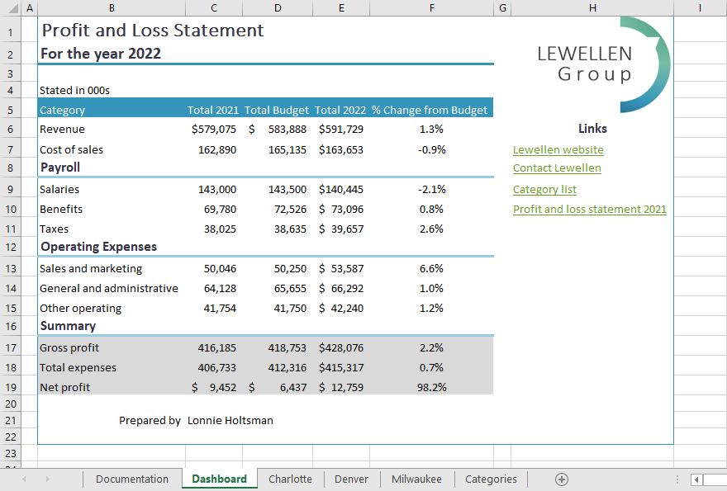

* Final Figure 2: Charlotte Worksheet

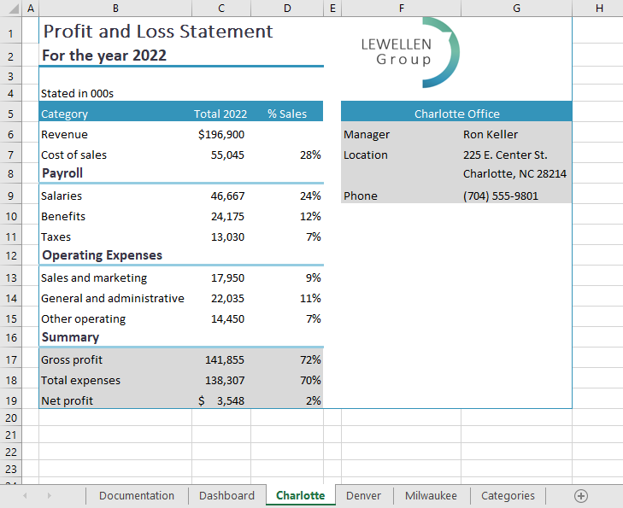

* Final Figure 3: Denver Worksheet

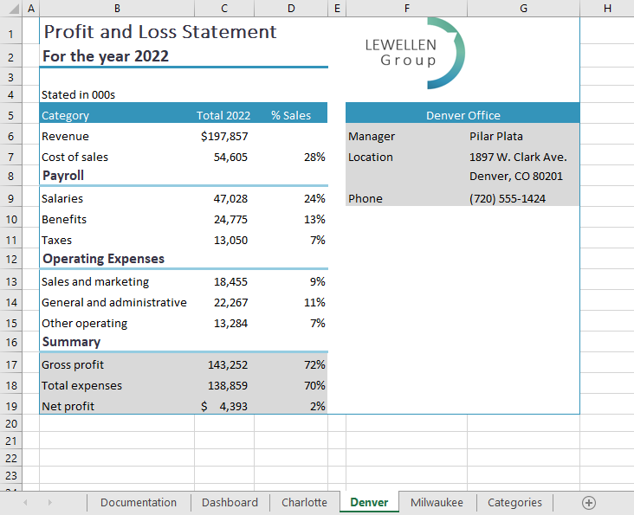

* Final Figure 4: Milwaukee Worksheet

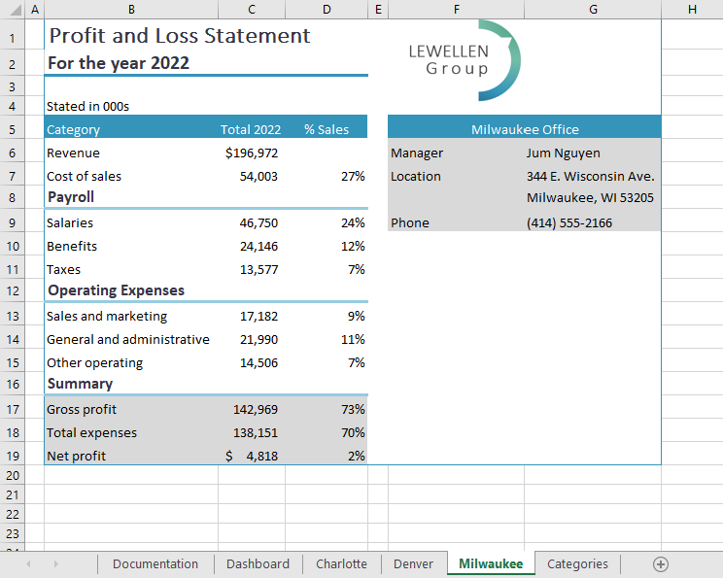

* Final Figure 5: Categories Worksheet

